Development Environment

# How to setup the development environment

## Code

May I suggest using Sublime Text 2 for coding? Anyway there’s workspace and project files for Sublime Text 2. <http://www.sublimetext.com/>

## Webserver

### DNS

If you’re like me, you might have several websites on your machine. I still prefer to use port 80, so I’ve configured DNS entries for every site.

1. Open the file C:\Windows\System32\drivers\etc\hosts as an administrator in a text editor.
2. Add: 127.0.0.1 wishlist.local
3. Verify: open cmd and exeute: ping wishlist.local

### Configure IIS

I’m a proud windows user :-) So I uses IIS as a web server. Need support for PHP thought.

1. Open IIS as an administrator
2. Use Web Platform Installer to enable PHP support (Currently PHP 5.6.0), FastCGI must be enabled. Update default_charset to "iso-8859-1" in php.ini and set short_open_tag to On
3. Add a new website

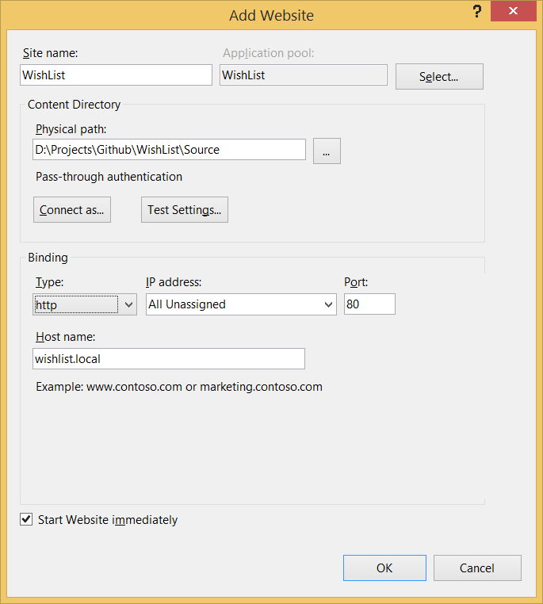

1. Open <http://wishlist.local/login.php>

## Database server

1. Install MySQL from (current MySQL 5.5)
2. Install MySQL Workbench (Nice to have)
3. Execute batch script restore.bat from folder Setup
4. Login to site using users from login.txt in folder Setup